Portal Page Site Plan

Fonts (Google Fonts):
Titles: | Sub-headings/Button Titles: | Paragraphs:
Noto Serif | Iosevka Charon | Instrument Sans

Colors:
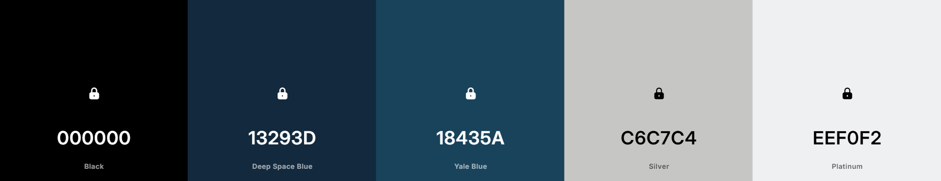

Logo (Will be rounded using CSS):


Wireframes:
Main Page: 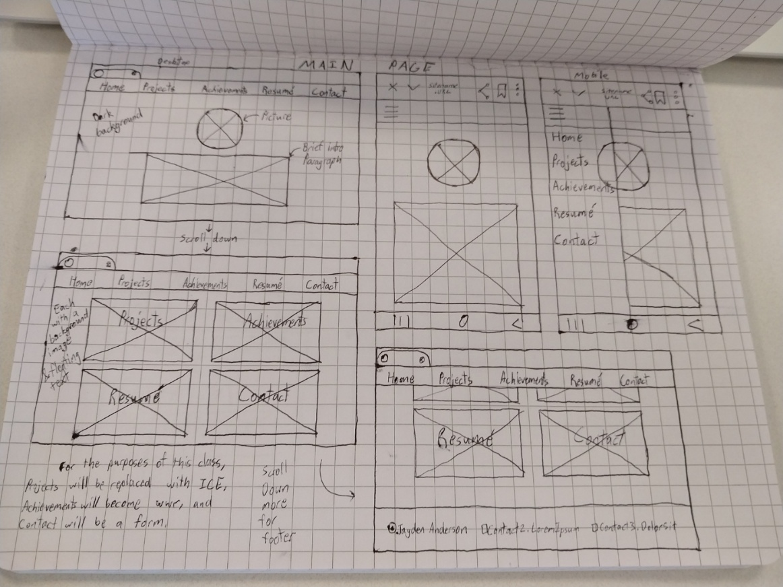

ICE Page: 